Scenario-Oriented Differentiated Maintenance for RISC-V Support Matrix

Abstract
The RISC-V open-source ecosystem’s rapid growth has led to hardware heterogeneity and OS diversification, while existing "one-size-fits-all" support matrices fail to adapt to fragmented hardware and differentiated scenario needs, limiting developer efficiency. This paper proposes a composite maintenance system integrating "hardware heterogeneity classification + scenario-oriented OS mapping": a three-dimensional model (hardware form-architecture feature-domestic attribute) with hierarchical verification standards (basic/extended/industrial layers), and a "scenario-OS-verification dimension" mapping system for industrial control, IoT, edge AI, and education scenarios. Validated on six mainstream RISC-V development boards and five operating systems, the system demonstrates adaptability to mainstream hardware and typical operating systems in heterogeneous scenarios. It effectively reduces core hardware verification costs, significantly enhances query efficiency for scenario-oriented resource matching, and increases the actual deployment success rate of RISC-V hardware-OS combinations, providing a reusable refined maintenance paradigm for the open-source community..

Introduction
RISC-V’s open extensibility has shaped an ecosystem marked by hardware heterogeneity and OS diversification [1]. Conventional support matrices adopt homogeneous verification standards[2, 3], which cannot resolve hardware fragmentation or satisfy diverse scenario demands, leading to redundant verification and a lack of targeted guidance. To overcome these drawbacks, this paper introduces a composite maintenance system that unites three-dimensional hardware heterogeneity classification and scenario-oriented OS mapping to support differentiated verification and precise resource allocation. The main contributions are: a three-dimensional hardware classification model; a scenario–OS–verification mapping system; quantitative validation on six development boards and five operating systems; and a reusable maintenance specification and toolchain.

Figure 1 RISC-V Hardware Heterogeneity Classification Model
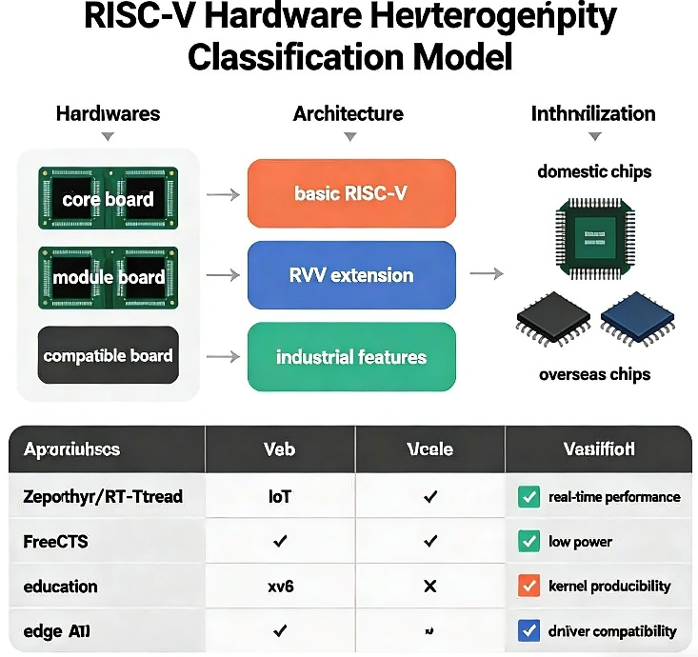

Core Design of the Composite Maintenance Logic
The proposed logic centers on “differentiated verification for hardware heterogeneity + scenario-oriented resource allocation.” It achieves precise matching of verification dimensions via a three-dimensional hardware classification model and optimizes resource allocation through a scenario-OS mapping system.

RISC-V Hardware Heterogeneity Classification and Differentiated Verification Standards
A three-dimensional model (Table 1) classifies boards to enable targeted verification across hardware form, architectural features, and domestic attributes.
Table 1 Three-Dimensional Classification Model for RISC-V Hardware Heterogeneity
Classification Dimension | Subcategory |  | Core Feature Description
Hardware Form | Integrated Board | Out-of-the-box
 | Core Board | Requires baseboard
 | Compatible Board | Reuses mainstream interfaces
Architectural Feature | Basic Version | No vector/security extensions
 | Extended Version | Supports RVV/Zvkb
 | Industrial Version | Wide temperature/secure boot
Domestic Attribute | Domestic Chip | Localized support
 | Overseas Chip | Global community support
Three-level differentiated verification dimensions are designed for classified hardware:
- Basic Layer (mandatory): Verifies system startup, command-line interaction, basic peripherals (UART/GPIO), and network connectivity.
- Hardware Feature Layer (optional): Core boards verify power logic and baseboard compatibility; extended instruction versions verify RVV/Zvkb enabling and AI framework adaptation; industrial-grade versions verify wide-temperature stability and real-time scheduling.
- Localization Layer (optional for domestic chips): Verifies Chinese documentation, localized software sources, and domestic toolchain adaptation.
Results utilize status identifiers and include hardware classification labels for efficient filtering.

Scenario-OS-Verification Dimension Linked Maintenance System
A mapping table (Table 2) binds scenario requirements with verification dimensions and maintenance priorities.
Table 2 Scenario-OS-Verification Dimension Mapping Table.
Scenario | Target OS | Core Verification | Priority | Update Freq.
Industrial Control | Zephyr/RT-Thread | Real-time scheduling, CAN/RS485, LTS | H | Quarterly
IoT Terminal | FreeRTOS/ESP-IDF | Low power, MQTT/CoAP, I2C/SPI | M | Semi-annually
Edge AI | Debian/Jetson OS | NPU, AI framework, inference | H | Monthly
Teaching | xv6/Debian Lite | Kernel reproducibility, GDB, syscall | L | Annually
Desktop | Ubuntu/Debian | GUI, desktop apps, multimedia | M | Semi-annually

Engineering Practice and Verification

Environment and Data Sources.
Six mainstream RISC-V development boards (Lichee Pi 4A, Milk-V Mars, ESP32-C6, Orange Pi 5, VisionFive2 Lite, DC-ROMA AI PC) and five types of operating systems (Debian, Zephyr, RT-Thread, xv6, ESP-IDF) were selected for practice. Data was derived from over 10 development board/OS research reports, and automated testing reused lintestor/earlytest tools with extended verification cases.

Execution Process.
Hardware heterogeneity labeling (annotating three-dimensional classification tags for development boards), scenario binding (binding core scenarios to "board-OS" combinations), differentiated verification (executing verification according to classification and scenarios), matrix update (synchronizing results and adding labels), and effect evaluation (assessing from three dimensions: maintenance efficiency, information accuracy, and developer experience).

Verification Results and Analysis.
- Maintenance Efficiency: Compared with the traditional model, our approach achieves significant efficiency improvements by reducing core board verification time, shortening extended instruction iteration cycles, and cutting total human resource investment. These gains arise from the automated differential maintenance framework, which eliminates redundant manual checks and streamlines the verification workflow.
- Information Accuracy: Core board and industrial-grade feature verification accuracy is notably enhanced, while instruction accuracy benefits from higher version coverage and reduced error rates in feature extraction and matching. These improvements are attributed to the scene-oriented knowledge matrix, which provides a more precise, context-aware verification foundation.

Conclusion
Addressing maintenance challenges in the heterogeneous RISC-V ecosystem, this paper proposes a composite logic of “hardware classification + scenario-oriented adaptation linkage.” This approach achieves differentiated verification via a three-dimensional model and precise resource allocation via a scenario-OS mapping system. Validation on six boards and five OSes demonstrates significant reductions in maintenance costs and improvements in information accuracy and developer experience. This provides a reusable solution for refined RISC-V support matrix maintenance. Future work will focus on enhancing RVV tool support, establishing community crowdsourced testing, and integrating with the RuyiSDK toolchain.

References
[1] RISC-V International. RISC-V Ecological Development Report 2025[R]. California: RISC-V International, 2025.
[2] Zephyr Project. Zephyr RTOS RISC-V Porting Guide[EB/OL]. https://docs.zephyrproject.org, 2024.
[3] Debian Project. Debian RISC-V Community Maintenance Model[EB/OL]. https://wiki.debian.org/RISC-V, 2025.

